Name: Karabo Pheko

Date: 27 August 2021

Project Name: Capstone Project

Description: A dynamic e-commerce website for online shopping of groceries.

Technologies:

* VS Code
* Notepad++
* Amazon Web Services, EC2 (Ubuntu) Instance (Host mean stack website for free)
* Docker (Containerizing the angular application)
* Node JS
* Angular (Frontend)
* MongoDB (Database)
* Express JS (Backend)
* Nginx Server
* Putty and PuttyGen
* Git and Github (Version control and project management)
* Postman and RestEasy (Making API requests)

GitHub Links:

* Front-end Angular Application: <https://github.com/PhekoK/capstone-project.git>
* Backend Express Server: <https://github.com/PhekoK/server.git>

Public IPv4 DNS:

* http://ec2-3-142-197-13.us-east-2.compute.amazonaws.com:80

Screenshots Creating Project – From Development to Production.

1. Development

* Backend – Express Server.

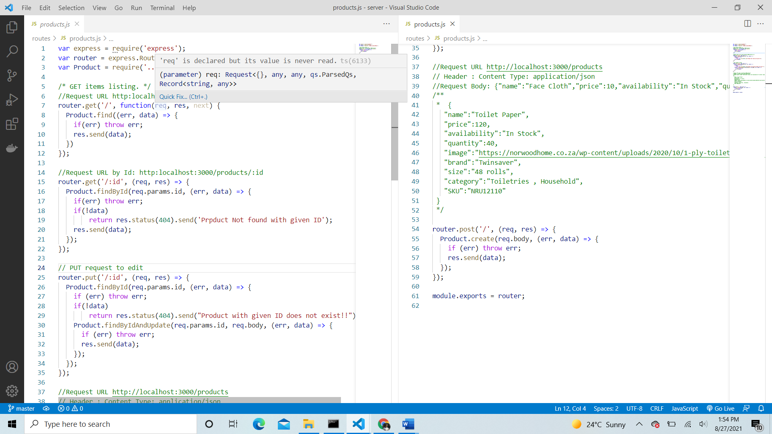



* app.js containing middleware

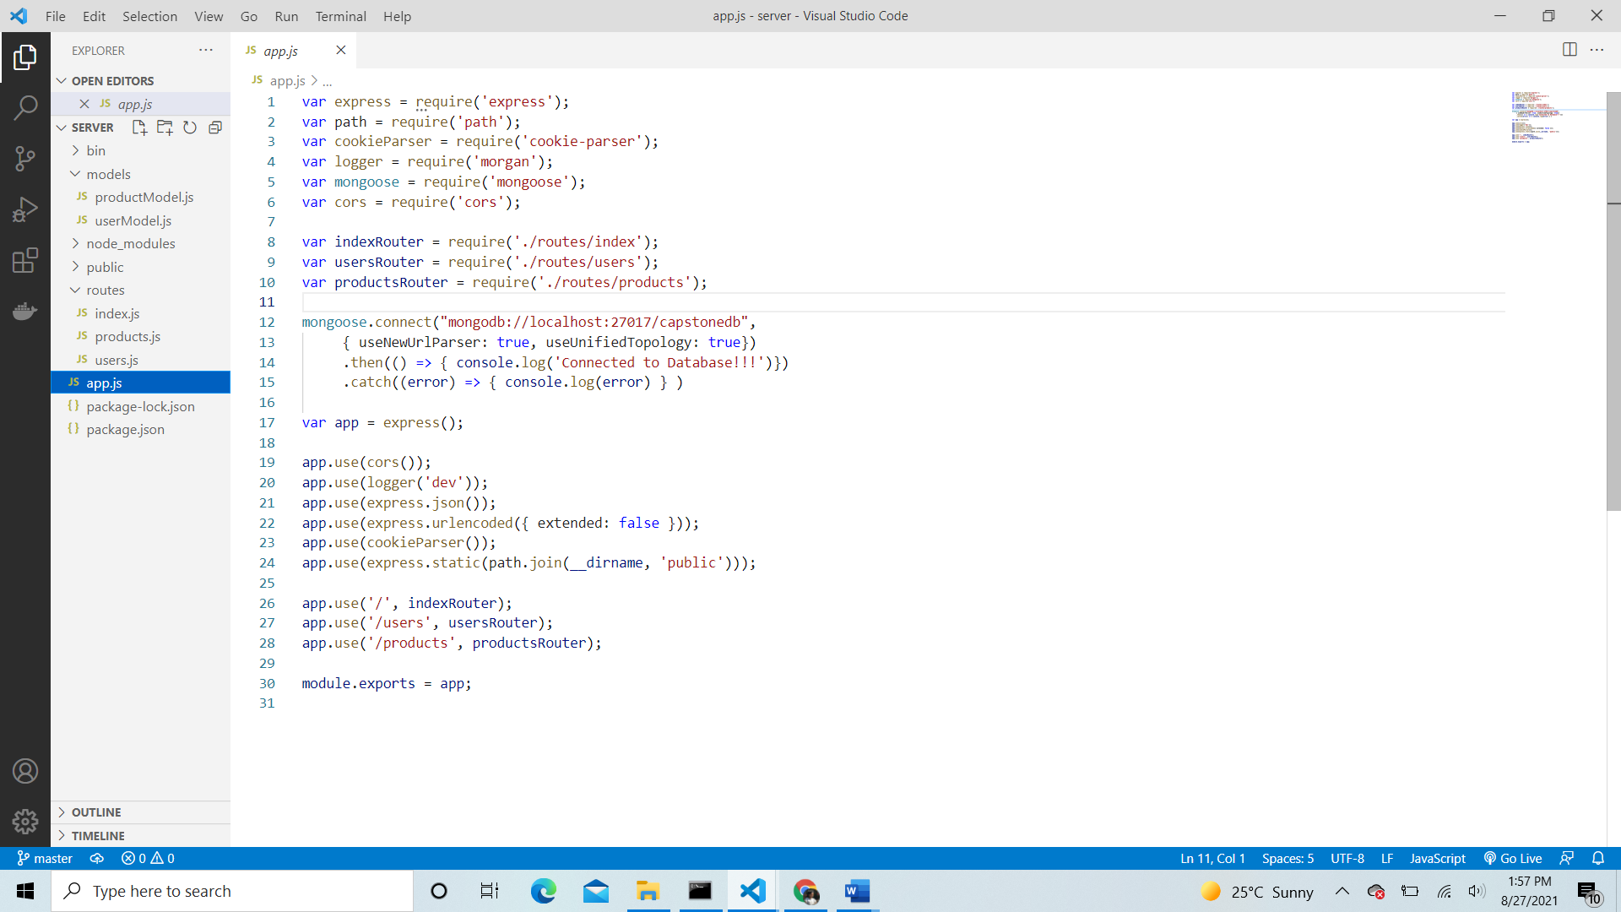

* API Requests – Used Postman and RestEasy to ensure API calls are working.

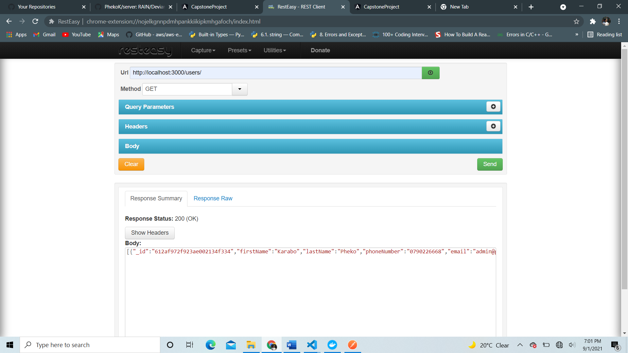

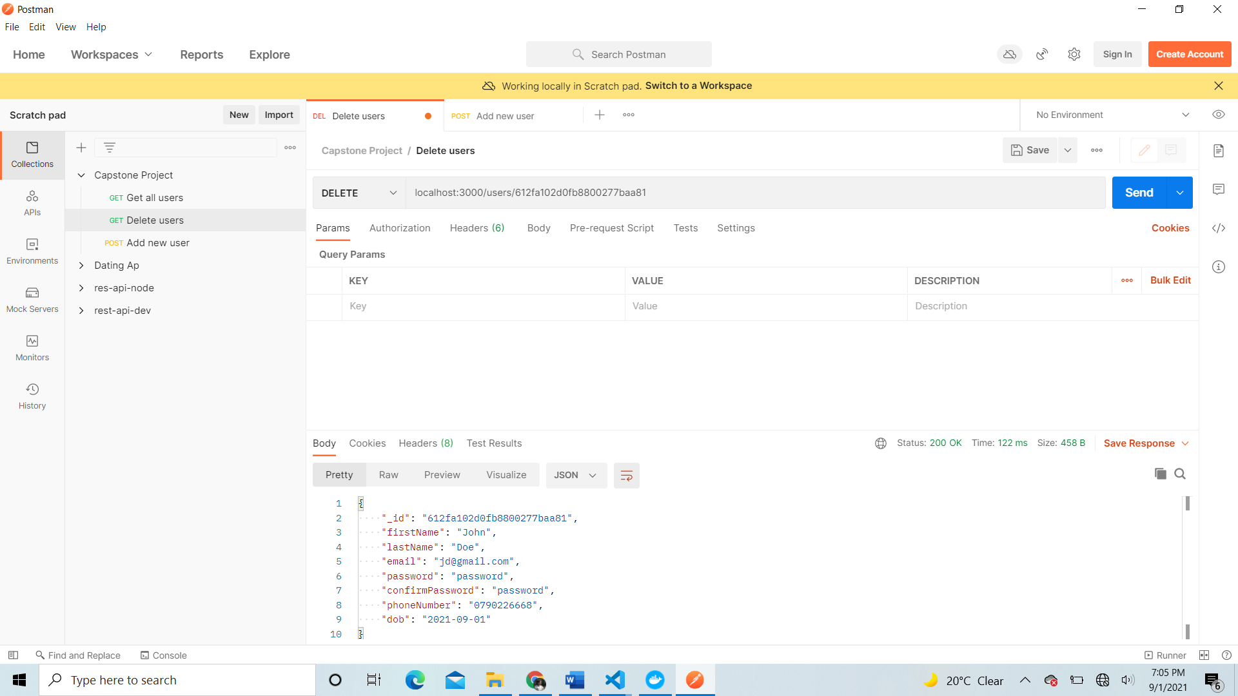

* Frontend – angular application
* User Portal
* Product viewing/catalogue page

* Login page

* Register page

* Shopping cart (if cart is not empty)

* Shopping cart (if cart is empty)

* Checkout page (takes billing information of user)

* Invoice page

* Admin portal
* Admin dashboard – product overview and manage users

* Product add page – admin can add a new product in product catalogue

* Delete existing items from product

* Update existing products

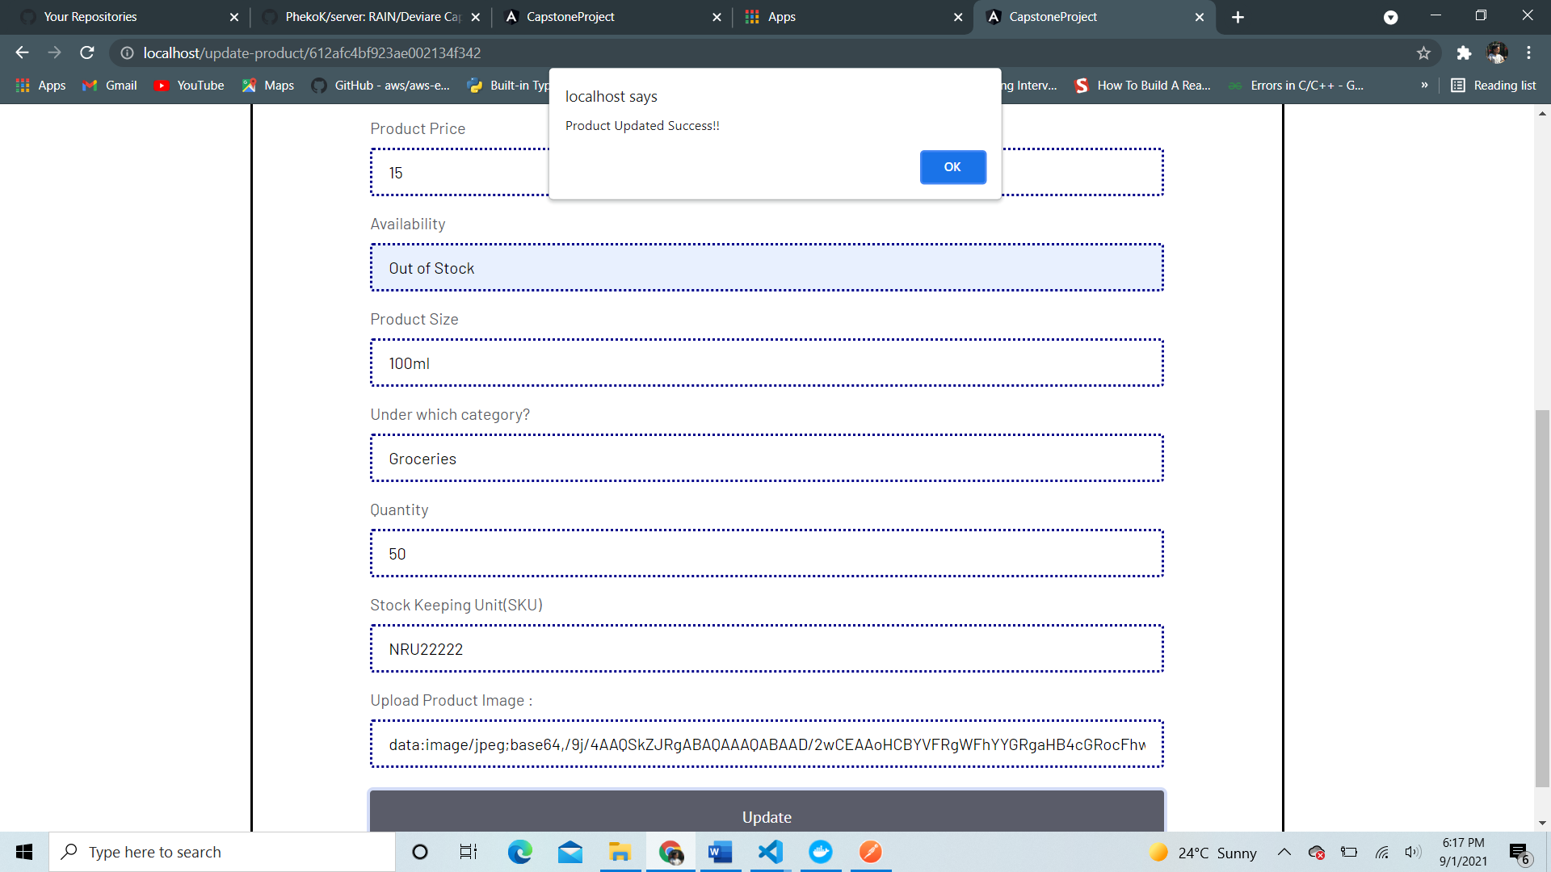

1. Production

* Containerize application using Docker
* Host to AWS EC2 instance